User Guide
This section explains how end users (Farmers and Vendors) can use the FarmVendor system.
1. Login / Registration
- Open: http://localhost:5173
- Register as:
- Farmer OR Vendor
- Login using credentials

- Register interface
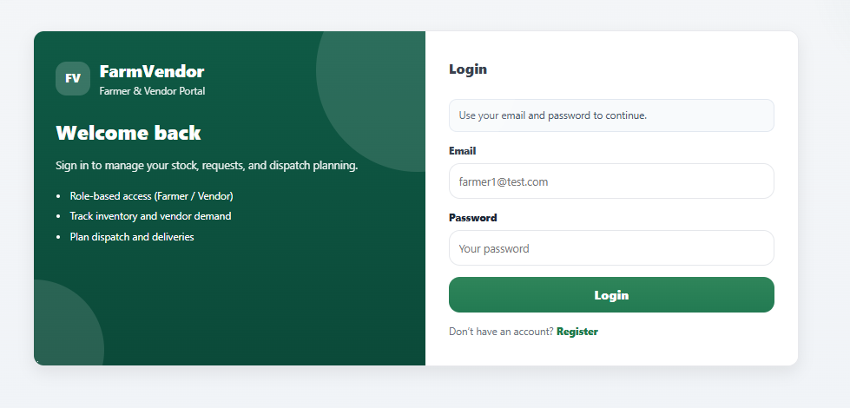

- Login interface
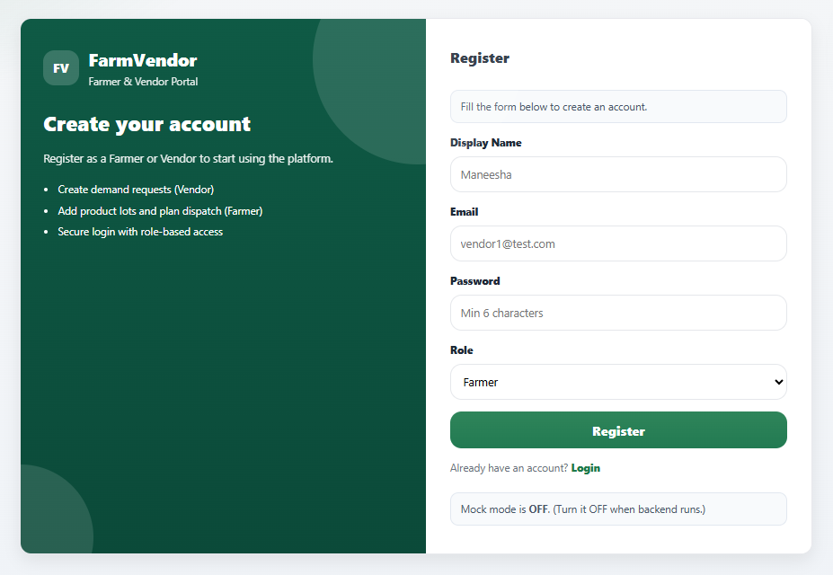

2. Farmer Functionalities
Dashboard
- View inventory summary
- View recommended vendors

- FarmerDashboard

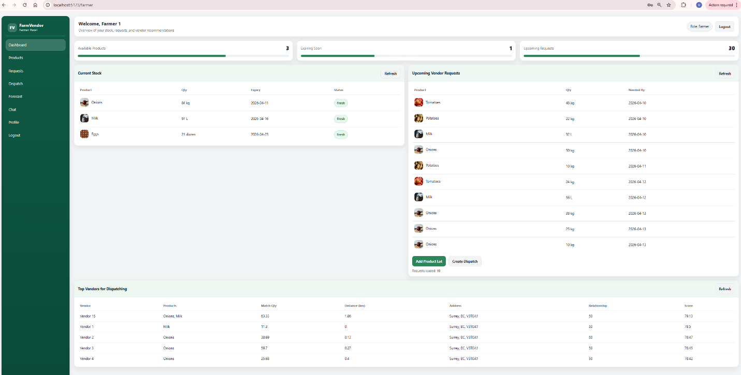

Inventory Management
- Add product lot
- Select product (with image from Unsplash)
- Enter quantity and expiry date

- FarmerDashboard
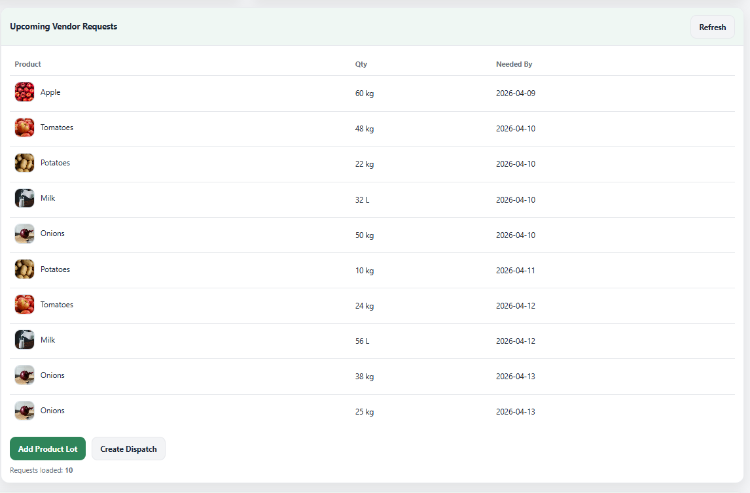

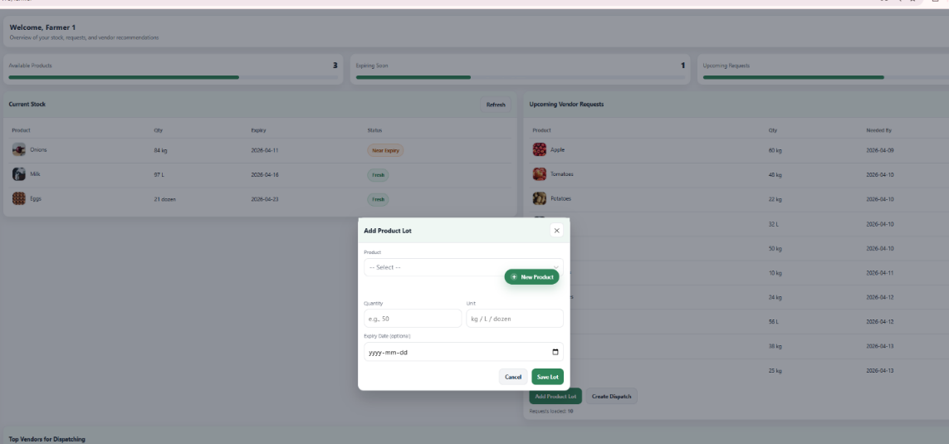

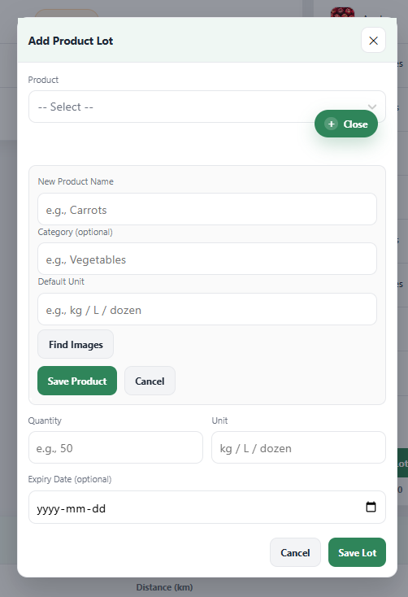

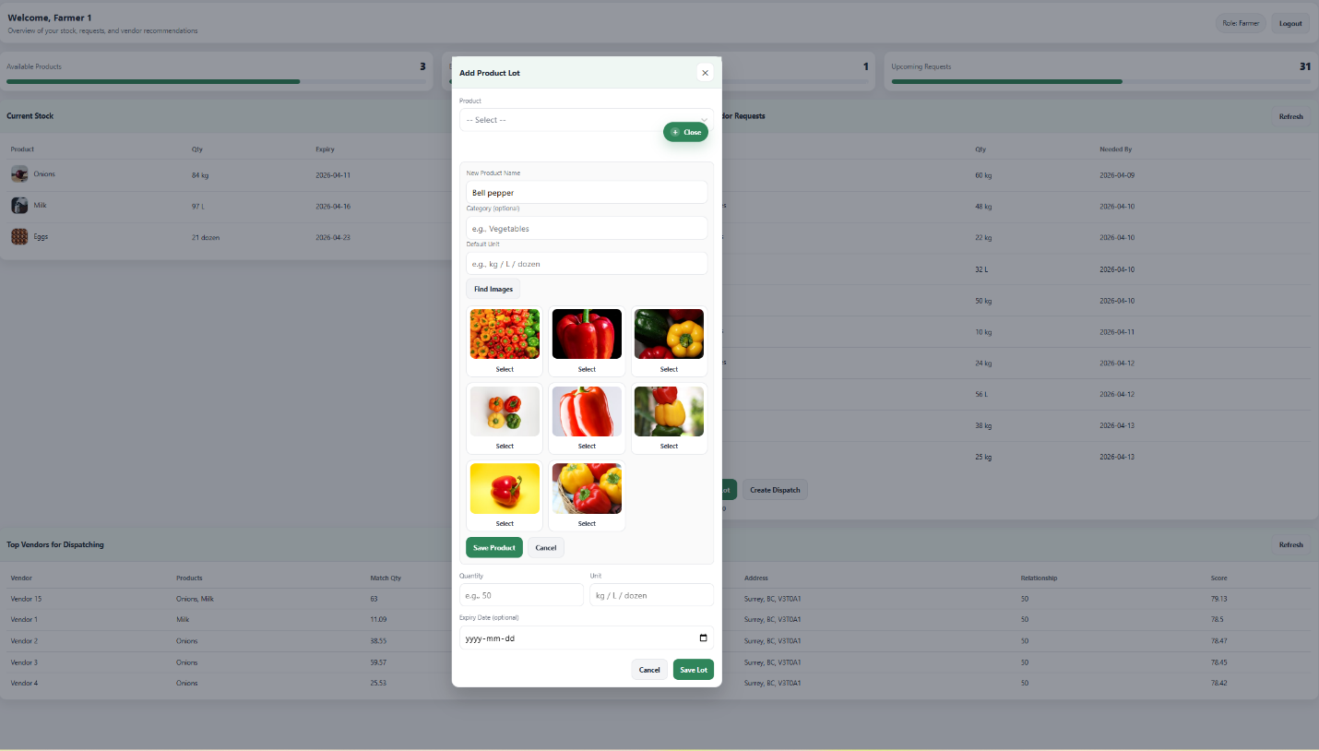

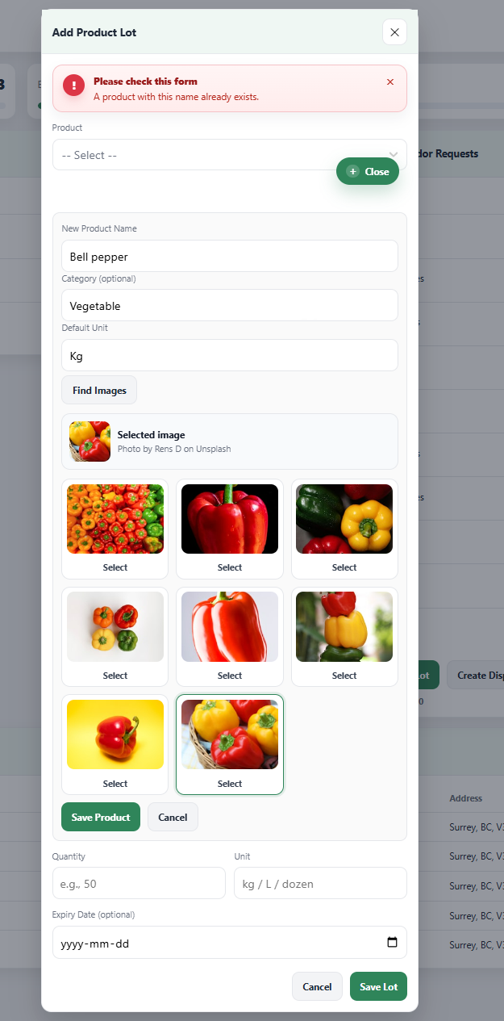

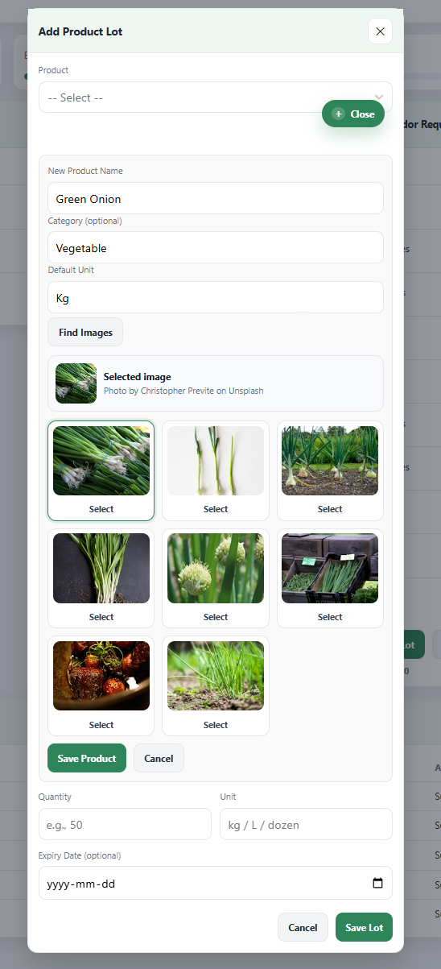

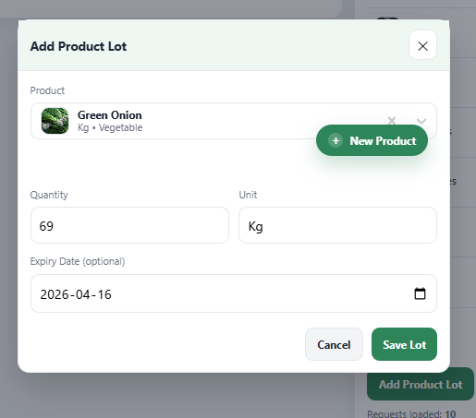

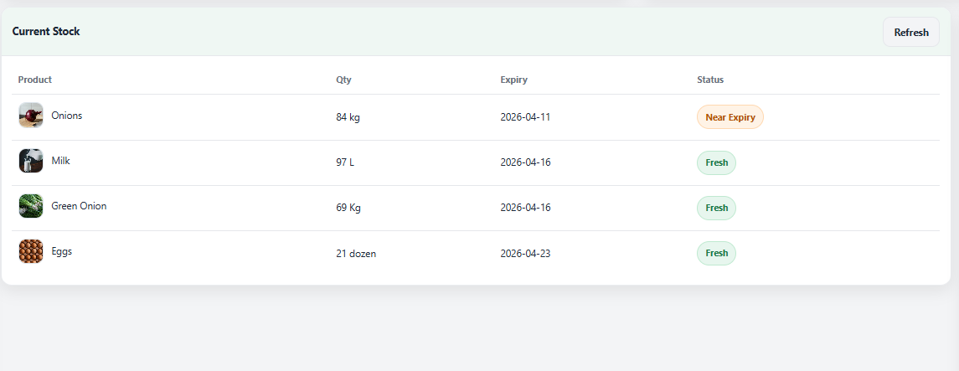

- Product interface

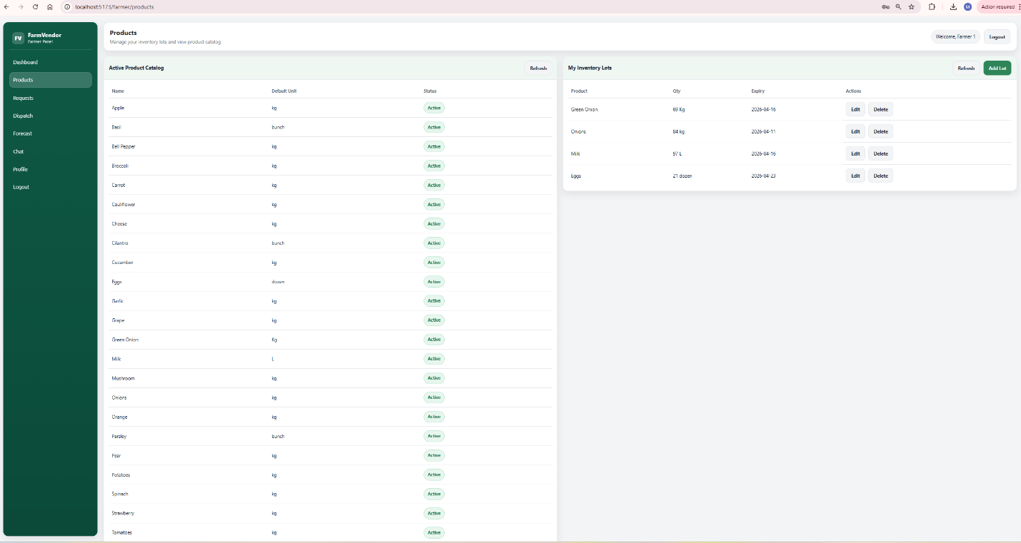

Demand Requests
- View vendor requests
- Track status

- VendorDashboard
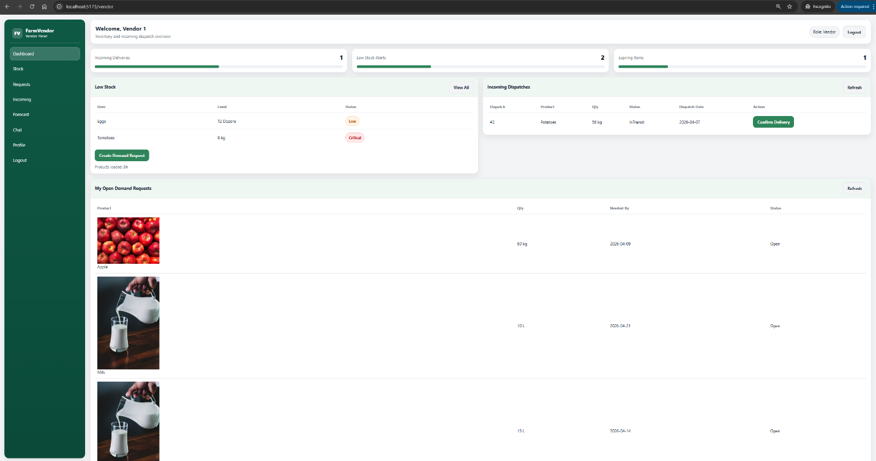

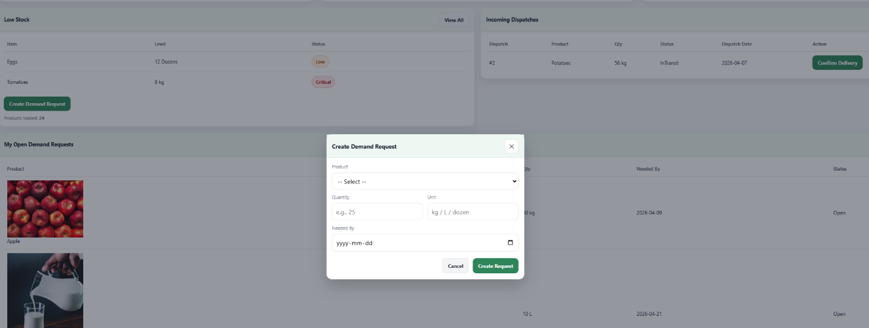

Dispatch Module
- Create dispatch for vendor requests
- Update delivery status

- FarmerDashboard

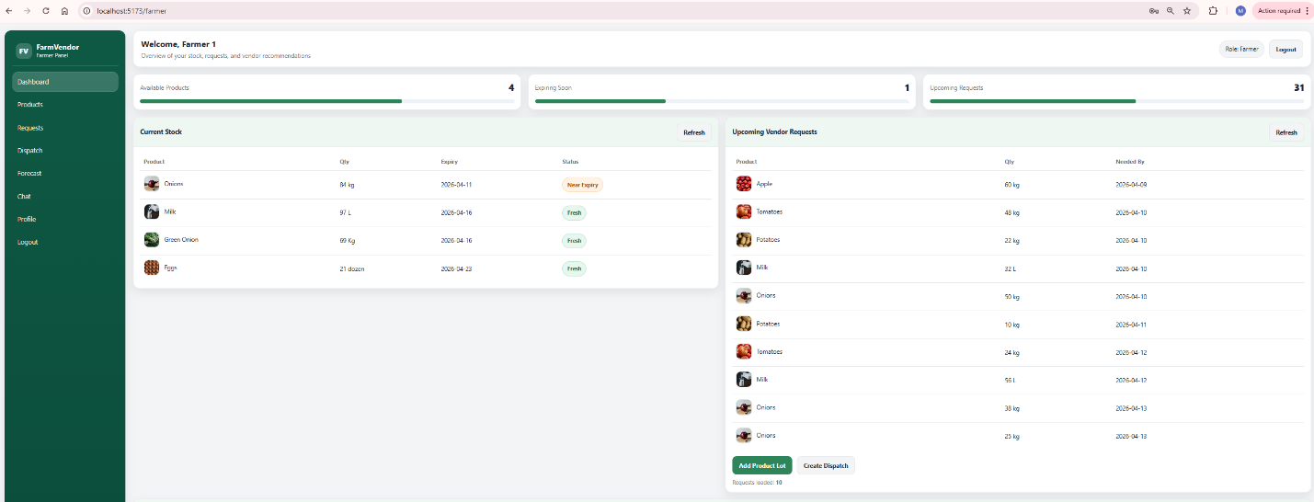

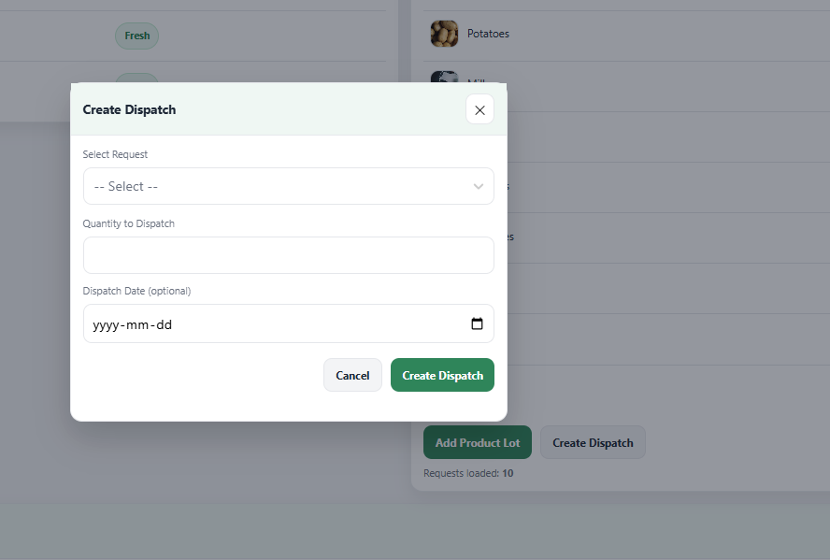

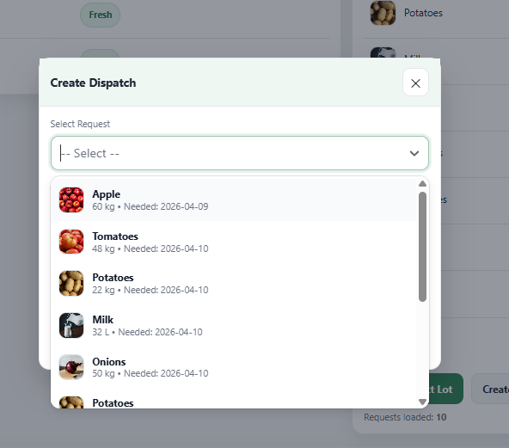

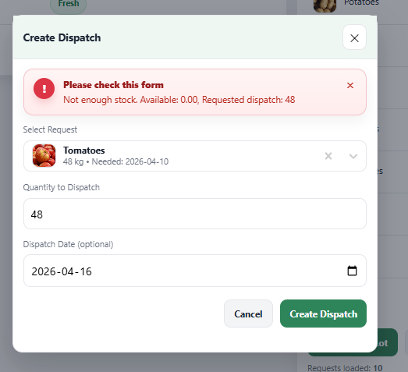

- Dispatch interface
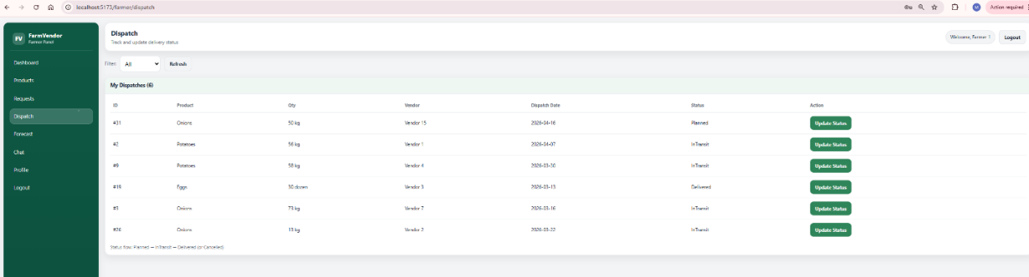

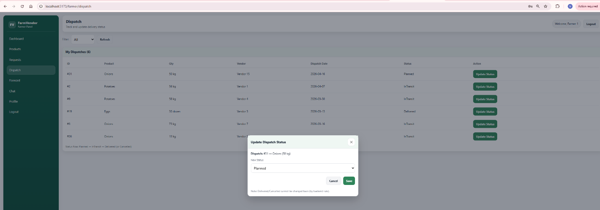

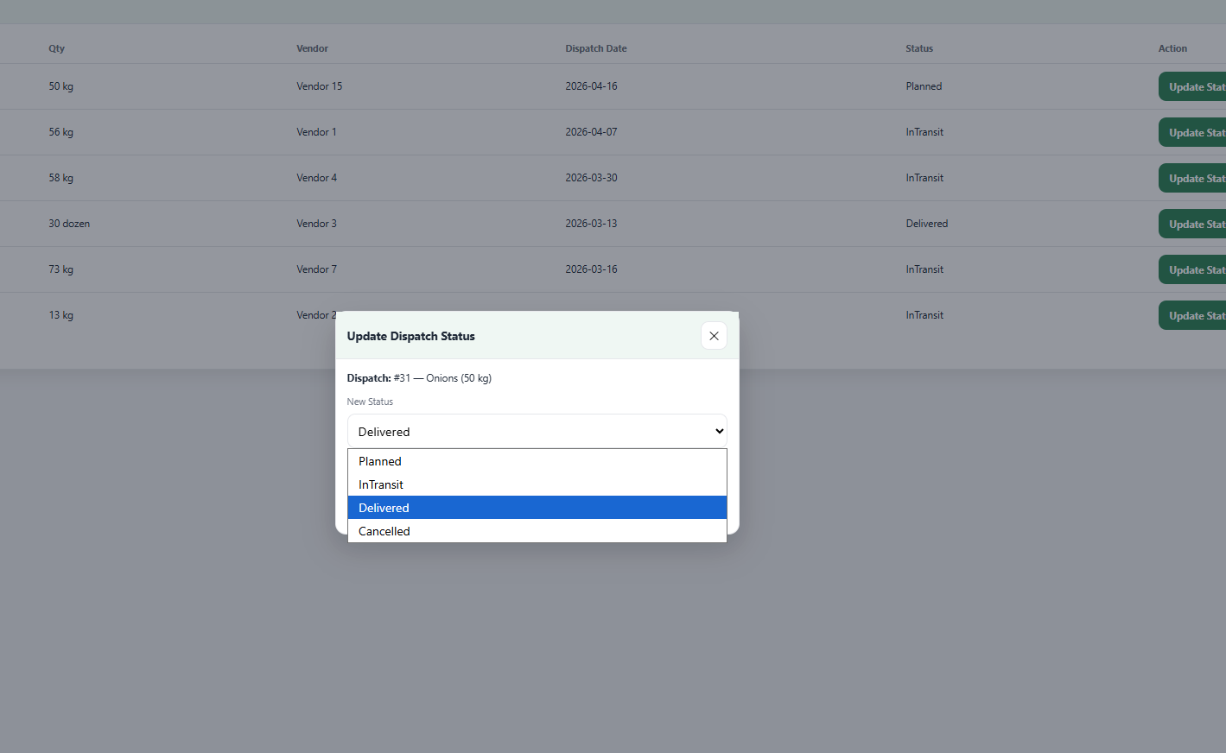

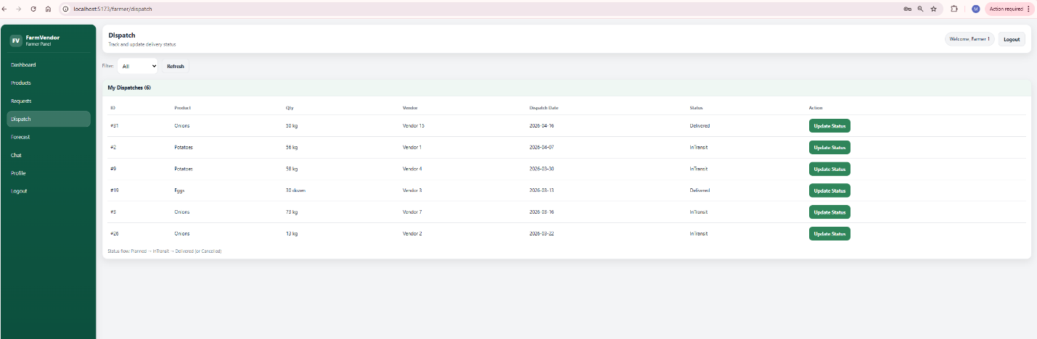

Vendor-dispatch incoming
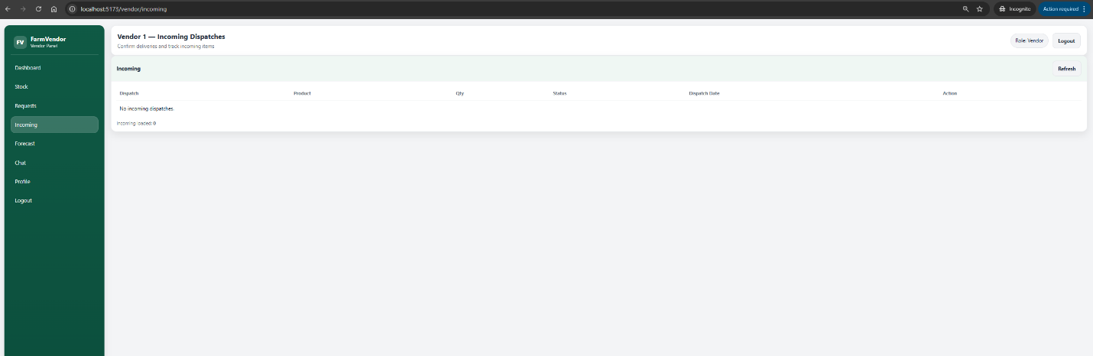

Forecast Dashboard
- Select vendor, product, and date
- Choose model (Moving Average / ML.NET SSA)
- View:
  - Forecast chart
  - Multi-vendor comparison
- Export results as CSV

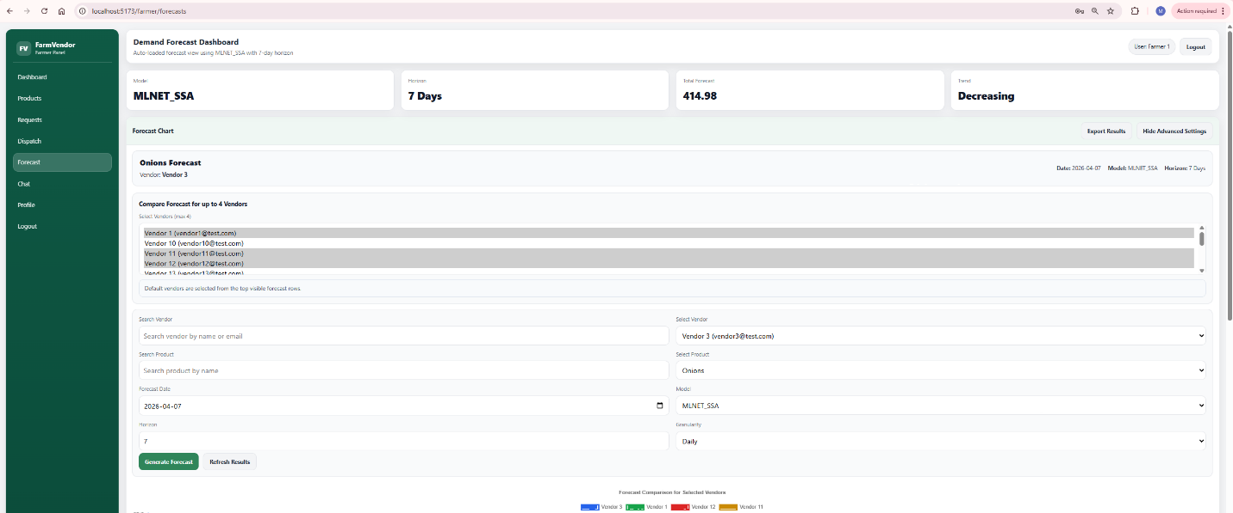

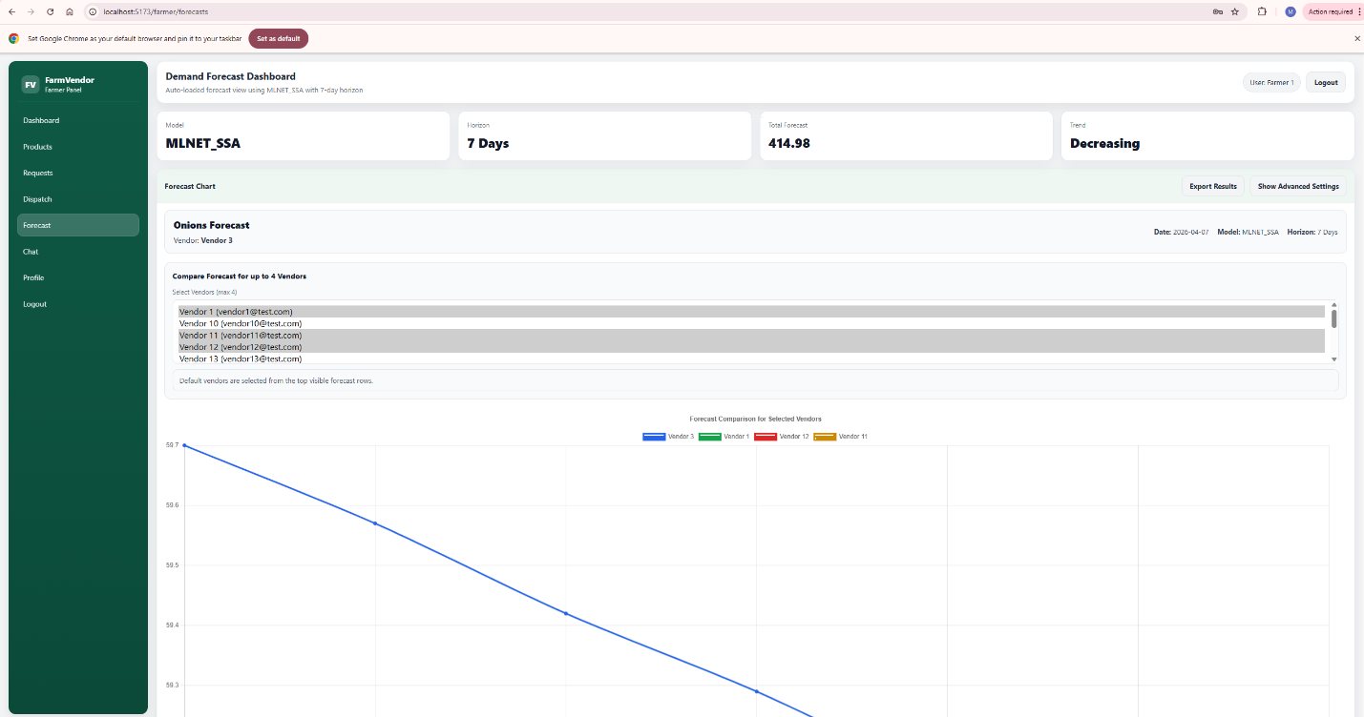

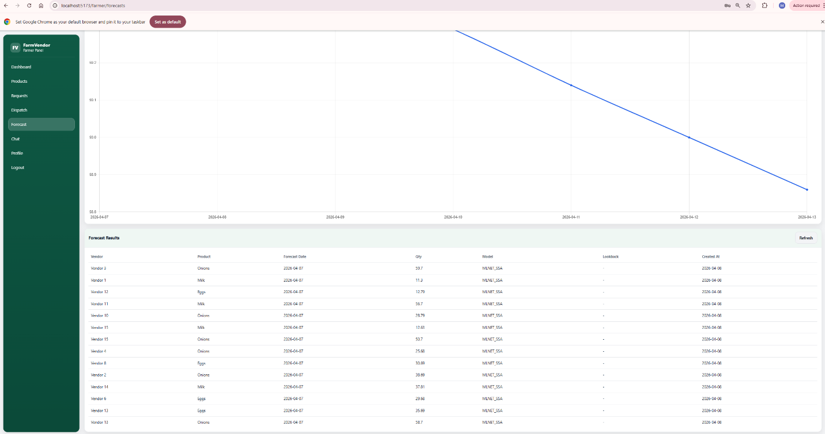

Chat Module
- Select vendor
- Start conversation
- Send and receive real-time messages

- farmerDashboard

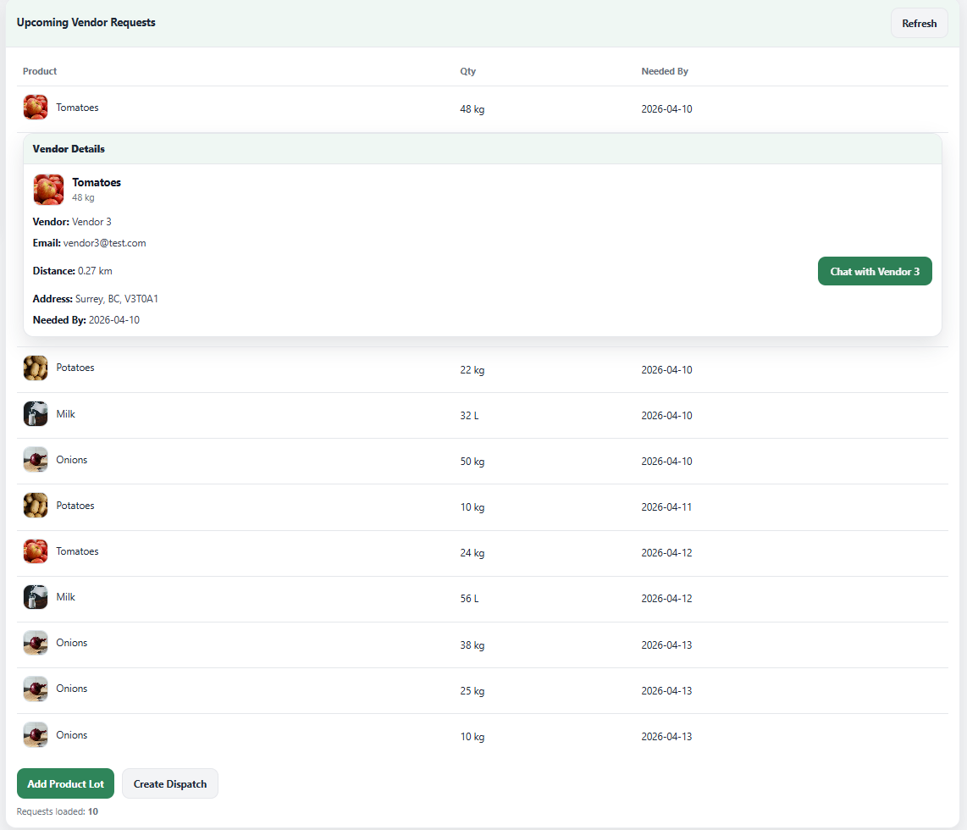

- Farmer chat panel
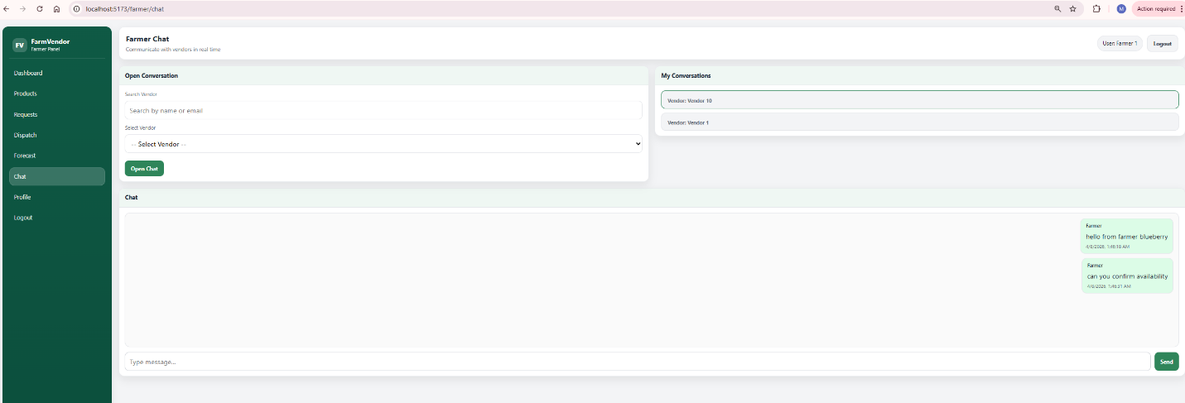

- Vendor chat panel
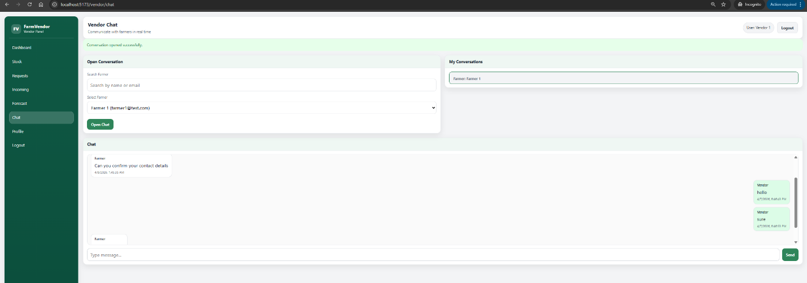

3. Vendor Functionalities
Dashboard
- View low stock alerts

- VendorDashboard


Demand Requests
- Create demand requests
- Track request status



Incoming Dispatches
- View deliveries from farmers
- Confirm delivery



Forecast Analytics
- View demand trends
- Compare forecasting models

Chat
- Communicate with farmers in real time

- Vendor chat panel


